
ADDIS KETEMA SECONDARY SCHOOL

JUN 11 2026
WEB – DESIGN PROJECT DOCUMENTATION GROUP- 4
PROJECT TITLE : STUDENT GRADING SYSTEM
SUBMITTED TO : TR. GEDEFAW
ABSTRACT

The management of student academic records is one of the most important responsibilities of educational institutions. In many schools, academic information such as grades, attendance records, and performance reports are still managed using manual methods or isolated spreadsheet applications. These approaches often result in calculation errors, data inconsistency, delayed access to information, and difficulties in maintaining academic records efficiently.

To address these challenges, the ADDIS KETEMA EDUTRACK system was developed as a web-based Student Grading and Performance Management System. The system is designed to provide a centralized platform that enables administrators, teachers, and students to manage and access academic information in a secure, organized, and efficient manner. Through role-based access control, each user is provided with functionalities that correspond to their responsibilities within the educational environment.

The system incorporates features such as student and teacher management, grade recording and processing, GPA calculation, attendance tracking, performance monitoring, announcements, notifications, and academic reporting. These features help improve the accuracy of academic record management while reducing the workload associated with traditional methods.

The development of the system was carried out using modern web technologies including React, TypeScript, HTML, CSS, JavaScript, Supabase, and Vite. The implementation followed a structured software development process involving system analysis, design, implementation, and testing. Various testing procedures were conducted to verify system functionality, security, usability, and reliability.

The results obtained from system evaluation indicate that the ADDIS KETEMA EDUTRACK platform successfully fulfills its intended objectives by improving academic information management, enhancing transparency, and providing timely access to student performance data. The project demonstrates how modern web-based technologies can be effectively utilized to support educational administration and contribute to the digital transformation of academic management systems.

ACKNOWLEDGEMENT

First and foremost, I would like to express my deepest gratitude to Allah, the Most Merciful and the Most Compassionate, for granting me the strength, patience, wisdom, and determination necessary to complete this project successfully. Without His guidance and blessings, this achievement would not have been possible.

I would also like to extend my sincere appreciation to my teachers and Addis Ketema School for providing the knowledge, support, and learning environment that contributed significantly to the successful completion of this project.

My heartfelt gratitude goes to my supporters: Megfira Mohammed, Nusra Miftah, and Adem Yassin. Their encouragement, motivation, advice, and continuous support played a significant role throughout the development of this project. During challenging moments, they inspired me to remain focused and continue working toward my goal. Their belief in my abilities gave me confidence whenever I faced difficulties, and their support became one of the strongest reasons behind the successful completion of this work.

I am truly grateful for their kindness, patience, and unwavering encouragement. This project would not have been completed in the same way without their valuable support and positive influence.

Finally, I would like to thank everyone who contributed directly or indirectly to the success of the ADDIS KETEMA EDUTRACK project. Your support and encouragement will always be remembered and appreciated.

Abdulwahid Nesru
11-06
Tue, Jun 2026

Table of Contents
CHAPTER ONE 6
INTRODUCTION 6
1.1 Background of the Study 6
1.2 Statement of the Problem 7
1.3 Motivation 7
1.4 General Objective 8
1.5 Specific Objectives 8
1.6 Scope of the Study 8
1.7 Significance of the Study 9
1.8 Organization of the Document 9
CHAPTER TWO 10
LITERATURE REVIEW 10
2.1 Introduction 10
2.2 Traditional Grading Systems 10
2.3 Spreadsheet-Based Academic Management Systems 11
2.4 Web-Based Academic Management Systems 11
2.5 Existing System Analysis 12
2.6 Comparative Analysis 12
2.7 Summary of the Chapter 13
CHAPTER THREE 14
SYSTEM ANALYSIS AND DESIGN 14
3.1 Introduction 14
3.2 Requirement Analysis 14
3.3 Functional Requirements 14
3.4 Non-Functional Requirements 16
3.5 System Architecture 16
3.6 User Role Logic 18
3.7 System Workflow 18
3.8 Database Design 19
3.9 UML Design Overview 20
3.10 ER Diagram Overview 22
3.11 Technology Stack Justification 23
3.12 Summary of the Chapter 23
CHAPTER FOUR 24
SYSTEM IMPLEMENTATION 24
4.1 Introduction 24
4.2 Example Screenshots 24
4.3 Sample Implementation Functions 26
4.4 Development Environment 29
4.5 System Implementation 29
4.6 Authentication and Security Implementation 31
4.7 Grade Processing and Performance Calculation 31
4.8 Challenges Encountered During Development 32
4.9 Summary of the Chapter 33
CHAPTER FIVE 34
TESTING AND EVALUATION 34
5.1 Introduction 34
5.2 Testing Methodology 34
5.2.1 Functional Testing 34
5.2.1 Integration Testing 35
5.2.2 User Interface Testing 35
5.2.3 Security Testing 35
5.3 Test Cases and Results 36
5.4 User Acceptance Testing (UAT) 36
5.5 System Evaluation 37
5.6 Summary of the Chapter 38
CHAPTER SIX 39
CONCLUSION, LIMITATIONS, AND RECOMMENDATIONS 39
6.1 Introduction 39
6.2 Conclusion 39
6.3 Limitations of the System 39
6.4 Recommendations 40
6.5 Future Enhancements 41
6.6 Final Remark 41
References 43
Appendix 44

CHAPTER ONE

INTRODUCTION

1.1 Background of the Study
The advancement of information and communication technology has significantly changed the way educational institutions manage academic activities. Many schools are gradually moving away from traditional paper-based systems and adopting digital solutions that improve efficiency, accuracy, and accessibility. One area that has particularly benefited from technological development is student academic record management.
In many educational institutions, student grades, attendance records, and performance reports are still managed manually through notebooks, printed documents, or spreadsheet applications. Although these methods have been used for many years, they often create challenges related to data organization, record security, accessibility, and accuracy. As the number of students increases, managing academic information manually becomes more difficult and time-consuming for teachers and administrators.
Student performance information plays a crucial role in the educational process. Teachers require accurate records to evaluate student achievement, administrators need reliable data for academic decision-making, and students need timely access to their results to monitor their progress. When academic information is managed inefficiently, delays, calculation errors, and data inconsistencies may occur, affecting the quality of educational services.
To address these challenges, the ADDIS KETEMA EDUTRACK system was developed as a web-based Student Grading and Performance Management System. The system provides a centralized platform where administrators, teachers, and students can interact with academic information according to their respective roles and responsibilities. Through digital record management, automated grade processing, attendance tracking, and performance monitoring, the system simplifies academic administration and improves the overall management of student information.
The system utilizes modern web technologies including React, TypeScript, Supabase, HTML, CSS, and JavaScript to provide a responsive and user-friendly environment. By implementing role-based access control and secure authentication mechanisms, the platform ensures that academic data remains organized, protected, and accessible to authorized users.
The development of ADDIS KETEMA EDUTRACK demonstrates the practical application of modern software technologies in solving real educational management challenges while contributing to the digital transformation of school administrative processes.

1.2 Statement of the Problem
Educational institutions depend heavily on accurate academic records to evaluate student performance and support effective decision-making. However, many schools continue to manage grading and student performance information using manual methods such as paper records or spreadsheet files. While these approaches may be suitable for small amounts of data, they become increasingly difficult to manage as the student population grows.
Manual grading systems often require significant time and effort from teachers and administrators. Academic records may be stored in multiple locations, making it difficult to maintain consistency and accuracy. Human errors in score calculation, data entry, and record management can negatively affect the reliability of student results. In addition, students may experience delays when accessing their academic information, limiting their ability to monitor their progress effectively.
Another challenge is the lack of centralized access to academic information. Teachers, students, and administrators often rely on separate records, which can create communication gaps and inconsistencies in the management of academic data. Furthermore, manual systems generally provide limited security measures, increasing the risk of data loss, unauthorized access, and record manipulation.
The absence of a centralized digital platform for managing grades, attendance, and performance tracking creates inefficiencies that affect the quality of educational administration. Therefore, there is a need for a secure, reliable, and user-friendly system capable of managing academic information in a more efficient and organized manner.
The ADDIS KETEMA EDUTRACK system was developed to address these challenges by providing a centralized web-based solution for academic performance management.

1.3 Motivation
The motivation behind the development of the ADDIS KETEMA EDUTRACK system originated from the challenges associated with managing academic records manually. In many educational institutions, grades, attendance records, and performance reports are maintained using paper documents or spreadsheet files, which often require significant effort to manage and update. These methods may lead to calculation errors, data inconsistency, and delays in accessing academic information.
As a student interested in software development and educational technology, I wanted to create a practical solution that could improve the efficiency of academic record management. The project also provided an opportunity to apply the knowledge and skills gained in web design, programming, database management, and software engineering. Therefore, the development of EDUTRACK was motivated by both the need to solve a real educational problem and the desire to gain practical experience in developing a complete web-based information system.

1.4 General Objective
The general objective of this project is to design and develop a web-based Student Grading and Performance Management System that improves the management, accessibility, accuracy, and security of academic records within educational institutions.

1.5 Specific Objectives
The specific objectives of the project are:
- To develop a centralized platform for managing student academic records.
- To provide administrators with tools for managing students, teachers, and academic information.
- To enable teachers to record, update, and monitor student grades efficiently.
- To allow students to access and monitor their academic performance in real time.
- To automate grade calculations and GPA generation.
- To improve data security through role-based access control and authentication mechanisms.
- To reduce errors associated with manual academic record management.
- To enhance communication and transparency between students, teachers, and administrators.

1.6 Scope of the Study
The scope of this project is limited to the development and implementation of a web-based academic performance management system for educational institutions. The system focuses primarily on student grading, attendance monitoring, performance tracking, and academic record management.
The system supports three primary user categories: administrators, teachers, and students. Administrators are responsible for managing users and overseeing academic activities throughout the system. Teachers are responsible for recording grades, monitoring student progress, and managing class-related information. Students are provided with access to their academic records, performance reports, attendance information, and grade history.
The system includes features such as secure authentication, role-based dashboards, grade management, GPA calculation, attendance tracking, announcements, notifications, and academic performance reporting. These functionalities are intended to improve the efficiency and accuracy of academic management processes.
However, the current version of the system does not include parent access portals, financial management modules, online learning features, or advanced artificial intelligence-based analytics. The system is primarily designed to support academic performance management within a school environment.

1.7 Significance of the Study
The significance of the ADDIS KETEMA EDUTRACK system lies in its ability to improve the management and accessibility of academic information within educational institutions.
For administrators, the system provides a centralized platform for monitoring academic activities and managing users efficiently. This improves administrative control and supports better decision-making through organized academic records.
For teachers, the system simplifies the process of recording and updating student grades while reducing the workload associated with manual calculations and record management. Teachers can monitor student performance more effectively and provide timely academic support when necessary.
For students, the platform offers immediate access to academic information, enabling them to monitor their progress and identify areas requiring improvement. This promotes greater transparency and encourages academic responsibility.
From a technological perspective, the project demonstrates how modern web technologies can be applied to solve practical educational challenges. The system contributes to ongoing efforts toward digital transformation in educational administration by replacing inefficient manual processes with a secure and scalable digital solution.

1.8 Organization of the Document
This document is organized into five chapters.
Chapter One presents the introduction, including the background of the study, statement of the problem, objectives, scope, significance, and overall organization of the report.
Chapter Two presents the literature review and discusses existing academic management approaches, related systems, and comparative analysis.
Chapter Three describes the system analysis and design, including requirement analysis, system architecture, UML diagrams, database design, and user role interactions.
Chapter Four discusses the implementation of the system, technologies used during development.
Chapter Five shows the Evaluation and Testing results.
Chapter Six presents the conclusion of the project, recommendations, and potential future enhancements for the system.

CHAPTER TWO

LITERATURE REVIEW

2.1 Introduction
Educational institutions generate and manage large amounts of academic information every academic year. Student grades, attendance records, teacher assignments, and performance reports are essential components of the educational process. Efficient management of this information is necessary to ensure accuracy, transparency, and effective decision-making.
Over the years, various approaches have been used to manage academic records. These approaches range from traditional paper-based systems to spreadsheet applications and modern web-based academic management platforms. Each approach has its own advantages and limitations. Understanding these systems helps identify existing challenges and provides a foundation for developing improved solutions.
This chapter reviews traditional and modern approaches used in academic record management and examines how the ADDIS KETEMA EDUTRACK system addresses the limitations of existing methods.

2.2 Traditional Grading Systems
Traditionally, schools managed student records using paper-based documentation. Teachers recorded grades manually in grade books, attendance sheets, and printed report forms. Student performance information was stored in physical files and maintained by teachers and administrative staff.
Although paper-based systems have been widely used for many years, they present several challenges. Managing large amounts of student information manually requires significant time and effort. As the number of students increases, maintaining accurate records becomes increasingly difficult. Human errors in score calculation, record updating, and report preparation may also affect the reliability of academic information.
Another limitation of traditional systems is the difficulty of accessing information. Academic records are often stored in separate locations, making it difficult for students, teachers, and administrators to retrieve information when needed. Furthermore, physical records are vulnerable to damage, loss, and unauthorized access.

Due to these limitations, many educational institutions have gradually adopted digital methods for managing academic information.

2.3 Spreadsheet-Based Academic Management Systems

With the increased availability of computers, many schools began using spreadsheet applications such as Microsoft Excel and Google Sheets to manage student records. These applications provide a more organized approach to storing and processing academic information compared to traditional paper-based systems.
Spreadsheet systems offer several advantages. They support automatic calculations, reduce some manual errors, and make data storage more convenient. Teachers can calculate averages, totals, and grades using built-in formulas, improving efficiency in academic record management.
Despite these benefits, spreadsheet-based systems still have several limitations. Data is often distributed across multiple files, creating difficulties in maintaining consistency and synchronization. Collaboration between multiple users may also become challenging when several teachers need to access or modify the same information. Security controls are generally limited, making it difficult to restrict access based on user roles.
In addition, spreadsheet systems do not provide integrated dashboards, real-time performance monitoring, or centralized user management. As a result, they are often insufficient for institutions seeking a comprehensive academic management solution.

2.4 Web-Based Academic Management Systems
Recent developments in web technologies have enabled the creation of comprehensive academic management systems that centralize educational information within a single platform. These systems allow multiple users to access academic records through secure online interfaces.
Web-based academic management systems typically include features such as student registration, grade management, attendance monitoring, report generation, user authentication, and performance tracking. Since information is stored in centralized databases, authorized users can access updated records from different locations and devices.

One major advantage of web-based systems is their ability to support role-based access control. Different users can access specific functionalities according to their responsibilities. Administrators manage system operations, teachers manage academic information, and students access their personal records without compromising data security.
Modern academic management systems also improve communication and transparency by providing real-time access to academic information. Students can monitor their progress regularly, while administrators can make informed decisions based on accurate and up-to-date data.
These advantages have made web-based solutions increasingly popular among educational institutions seeking to improve efficiency and service quality.

2.5 Existing System Analysis
Before the development of ADDIS KETEMA EDUTRACK, many schools relied on combinations of manual record keeping and spreadsheet-based academic management. While these approaches provided basic support for grading and record storage, they presented several operational challenges.
Academic information was often stored in different locations and managed by multiple individuals, resulting in inconsistencies and delays. Teachers spent considerable time calculating grades and preparing reports manually. Students frequently experienced difficulties accessing their academic results promptly. Administrators also faced challenges in monitoring academic activities across the institution.
Furthermore, existing methods lacked centralized security controls and structured access management. Unauthorized modifications, accidental data loss, and record duplication were common concerns. As educational institutions increasingly depend on accurate academic information, these limitations highlight the need for a more efficient and reliable solution.
The ADDIS KETEMA EDUTRACK system was developed specifically to address these challenges through centralized academic management, automated grade processing, secure authentication, and role-based access control.

2.6 Comparative Analysis
A comparison of traditional systems, spreadsheet-based systems, and the proposed EDUTRACK system demonstrates the improvements offered by the developed solution.
Traditional paper-based systems provide limited accessibility and require extensive manual effort. Spreadsheet systems improve calculation accuracy but still suffer from limited collaboration, security concerns, and fragmented data management.
The ADDIS KETEMA EDUTRACK system introduces a centralized web-based platform that integrates student management, teacher management, grading, attendance tracking, notifications, announcements, and academic performance monitoring into a single environment. The system provides secure access through authentication mechanisms and role-based permissions, ensuring that users can access only the information relevant to their responsibilities.
Additionally, automated grade processing reduces calculation errors, while real-time information availability improves transparency and communication among administrators, teachers, and students. These capabilities make the proposed system more efficient, secure, and scalable than traditional and spreadsheet-based approaches.

2.7 Summary of the Chapter
This chapter reviewed the evolution of academic record management systems from traditional paper-based methods to modern web-based solutions. The analysis identified several limitations associated with manual and spreadsheet-based systems, including inefficiency, data inconsistency, limited accessibility, and security challenges.
The review also demonstrated the advantages of centralized web-based academic management platforms. Based on these findings, the ADDIS KETEMA EDUTRACK system was developed to provide a secure, efficient, and user-friendly solution for managing student academic information and improving educational administration.

CHAPTER THREE

SYSTEM ANALYSIS AND DESIGN

3.1 Introduction
System analysis and design is one of the most important phases in software development. It involves identifying system requirements, understanding user needs, defining system functionality, and creating a structured design that guides the implementation process.
The purpose of this chapter is to describe the analysis and design activities carried out during the development of the ADDIS KETEMA EDUTRACK system. It presents the system requirements, architectural design, database structure, user roles, and overall system workflow.
The design of the system was guided by the objective of creating a secure, efficient, and user-friendly platform capable of managing student academic information while reducing the challenges associated with manual record management.

3.2 Requirement Analysis
Requirement analysis is the process of identifying the services and functionalities that the system must provide to satisfy user needs. The analysis was conducted by examining the academic management activities performed by administrators, teachers, and students.
The findings indicated that users required a centralized platform capable of managing academic records, monitoring student performance, processing grades, and providing secure access to authorized users.
The requirements identified during the analysis process were categorized into functional and non-functional requirements.

3.3 Functional Requirements
Functional requirements describe the specific services and operations that the system must perform.

Administrator Requirements
The administrator is responsible for managing the overall operation of the system. The system must allow administrators to:
- Register new students and teachers.
- Update student and teacher information.
- Remove inactive or incorrect records.
- Monitor academic activities throughout the system.
- Manage announcements and notifications.
- Assign teachers to classes and subjects.
- View reports and academic statistics.
- Manage user accounts and access permissions.
Teacher Requirements
Teachers are responsible for academic performance management within assigned classes. The system must allow teachers to:
- View assigned classes and students.
- Record student grades.
- Update existing academic records.
- Monitor student performance.
- Manage attendance information.
- View class performance summaries.
- Access academic reports related to their classes.
Student Requirements
Students are the end users of the system. The system must allow students to:
- Access their personal dashboard.
- View grades and GPA results.
- Monitor academic progress.
- View attendance records.
- Receive announcements and notifications.
- Access academic history and performance reports.

3.4 Non-Functional Requirements
Non-functional requirements describe the quality attributes and operational characteristics of the system.
Performance Requirements
The system should respond quickly to user requests and provide smooth navigation between pages and dashboards.
Security Requirements
The system must protect academic information from unauthorized access. Authentication and role-based access control mechanisms must be implemented to ensure data security.
Reliability Requirements
The system should provide consistent performance and maintain data accuracy during operation.
Scalability Requirements
The architecture should support future expansion and accommodate additional users and functionalities when necessary.
Usability Requirements
The system should provide a simple and intuitive interface that can be used effectively by administrators, teachers, and students with minimal training.
Maintainability Requirements
The code structure should be modular and organized to simplify future updates, debugging, and maintenance activities.

3.5 System Architecture
The ADDIS KETEMA EDUTRACK system follows a three-tier architecture model consisting of the Presentation Layer, Application Layer, and Data Layer.
Presentation Layer
The Presentation Layer is responsible for user interaction and interface rendering. It provides dashboards and forms through which users interact with the system.
Major interface components include:
- Login Page
- Admin Dashboard
- Teacher Dashboard
- Student Dashboard
- Notification Interface
- Attendance Interface
- Grade Management Interface
The frontend was developed using React, TypeScript, HTML, CSS, and JavaScript.
Application Layer
The Application Layer contains the business logic of the system. It processes user requests, applies validation rules, calculates grades and GPA values, manages authentication, and controls user permissions.
Key responsibilities include:
- Authentication processing
- Grade calculations
- GPA generation
- Attendance management
- Role-based authorization
- Notification handling
- Data validation
Data Layer
The Data Layer stores and manages all system information.
The database contains information related to:
- Students
- Teachers
- Grades
- Attendance
- Subjects
- Announcements
- Notifications
- User Accounts
Supabase is used as the primary backend database solution due to its scalability, security, and cloud-based accessibility.

3.6 User Role Logic
The system operates using a role-based access control model that defines different privileges for each user category.
Administrator Logic
Administrators possess the highest level of authority within the system. They have access to all system modules and can perform Create, Read, Update, and Delete (CRUD) operations on academic records.
Administrators are responsible for maintaining data integrity, managing users, assigning teachers, and monitoring academic activities.
Teacher Logic
Teachers have controlled access based on their assigned classes and subjects. They can update grades, monitor attendance, and evaluate student performance.
Teachers are restricted from accessing administrative functions and can only manage information related to their assigned responsibilities.
Student Logic
Students have read-only access to personal academic information. They can view grades, GPA results, attendance records, announcements, and performance summaries.
Students cannot modify academic records or access information belonging to other users.

3.7 System Workflow
The operational workflow of the system follows a structured sequence of activities.
Step 1:
The user enters login credentials through the authentication interface.
Step 2:
The system verifies user information and identifies the associated role.
Step 3:
The appropriate dashboard is loaded based on the authenticated role.
Step 4:
The user performs authorized actions within the system.
Step 5:
The system processes requests and updates records when necessary.
Step 6:
Updated information is stored in the database.
Step 7:
Relevant users can access the updated information in real time.
This workflow ensures consistency, security, and efficient academic data management.

3.8 Database Design
The database is designed to support the storage and management of academic information.
The primary entities within the system include:
Student
Stores student information including identification details, class information, attendance records, and academic performance data.
Teacher
Stores teacher information including assigned subjects and classes.
Subject
Stores information related to academic subjects offered within the institution.
Grade
Stores assessment results, examination scores, GPA values, and performance records.
Attendance
Stores student attendance information and related statistics.
Announcement
Stores school announcements and important notifications distributed to users.
User Account
Stores authentication credentials and role information required for secure system access.
The relationships among these entities ensure efficient organization and retrieval of academic information.

3.9 UML Design Overview
Unified Modeling Language (UML) diagrams were used to visualize system functionality and user interactions.
The following diagrams were prepared during the design phase:
- Use Case Diagram
- Activity Diagram
- Sequence Diagram
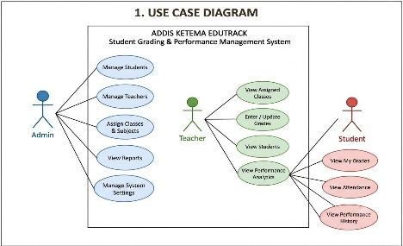
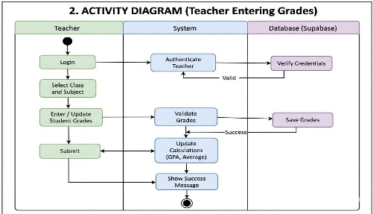
- Entity Relationship Diagram

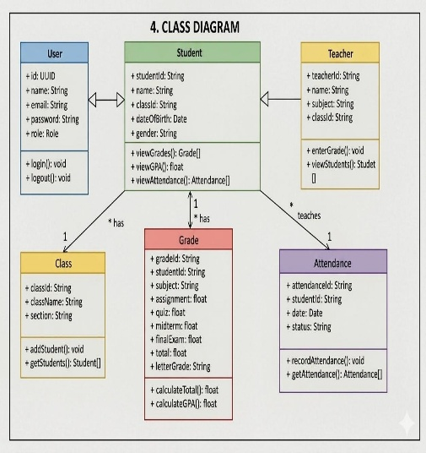
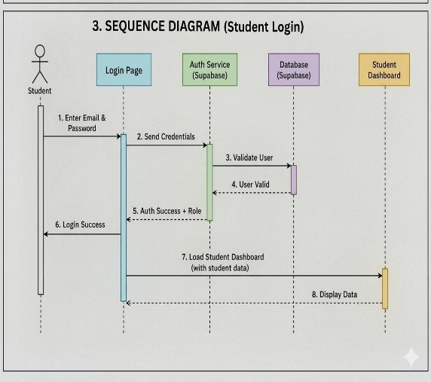
These diagrams provide a graphical representation of system behavior, user interactions, and data relationships.

3.10 ER Diagram Overview

├── .env.example # Environment variables template (Supabase keys, configs)
├── .gitignore # Files excluded from version control
├── index.html # Main HTML entry point of the app
├── metadata.json # App configuration and metadata
├── package.json # Project dependencies and scripts
├── tsconfig.json # TypeScript configuration
├── vite.config.ts # Vite build & development configuration
│
└── src/
├── assets/ # Static files (images, logos, icons)
│
├── components/ # UI pages & dashboards
│ ├── AdminDashboard.tsx # Admin control panel (manage users & system)
│ ├── TeacherDashboard.tsx # Teacher panel (grades & class management)
│ ├── StudentDashboard.tsx # Student panel (view results only)
│ ├── LoginPage.tsx # Authentication page (role-based login)
│ ├── SplashWelcome.tsx # Intro/loading screen
│ └── AvatarCam.tsx # Profile/avatar handling UI
│
├── data/ # Core logic & temporary data storage
│ └── mockData.ts # Students, teachers, grade logic, state updates
│
├── App.tsx # Main app structure & routing
├── main.tsx # React entry point

3.11 Technology Stack Justification
The technologies used in the development of the ADDIS KETEMA EDUTRACK system were selected based on their reliability, scalability, and suitability for modern web application development.
React was chosen because it supports component-based development, making the user interface easier to organize and maintain. TypeScript was selected to improve code quality and reduce development errors through static type checking.
Supabase was chosen as the backend platform because it provides database management, authentication services, and cloud-based data storage within a unified environment. Vite was selected as the build tool due to its fast development performance and efficient project compilation.
Together, these technologies provided a strong foundation for developing a responsive, secure, and maintainable academic management system.

3.12 Summary of the Chapter
This chapter presented the analysis and design of the ADDIS KETEMA EDUTRACK system. It discussed system requirements, architecture, database structure, user role logic, and overall workflow. The design decisions described in this chapter provided the foundation for the implementation of a secure and efficient academic performance management platform.
The next chapter focuses on the implementation process, technologies used during development, testing procedures, and system evaluation.

CHAPTER FOUR

SYSTEM IMPLEMENTATION

4.1 Introduction
After completing the system analysis and design phase, the next step involved the implementation of the ADDIS KETEMA EDUTRACK system. This phase focused on converting the system design into a functional web-based application capable of managing student academic records, grades, attendance, and performance information.
The implementation process involved the integration of frontend technologies, backend services, authentication mechanisms, and database management tools. Once development was completed, various testing procedures were conducted to ensure that the system functioned correctly and satisfied the identified requirements.
This chapter describes the development environment, implementation process of the system.

4.2 Example Screenshots
Administrator Module
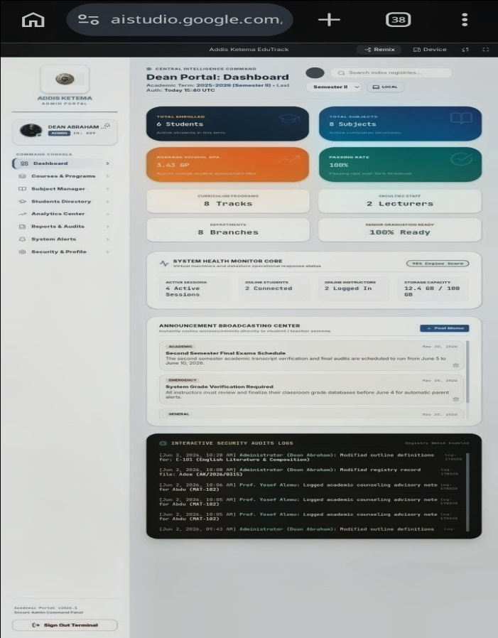

Teacher Module
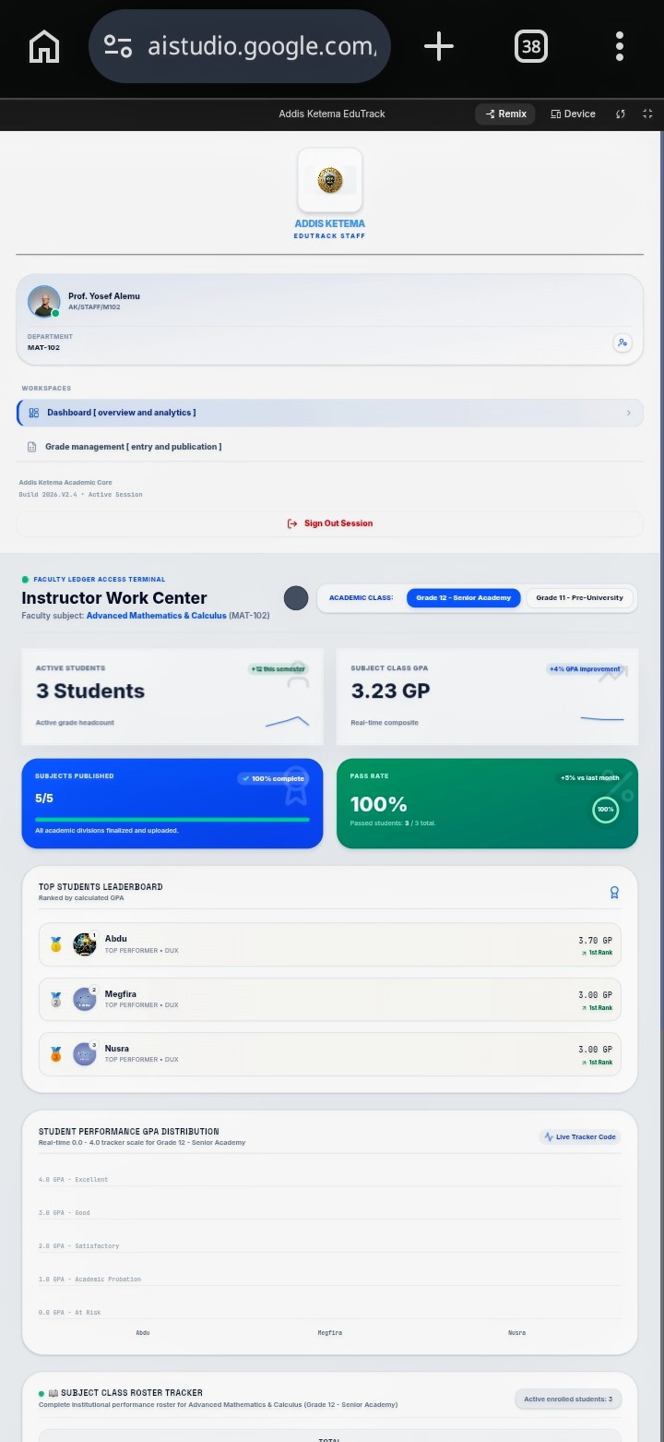

Student Module

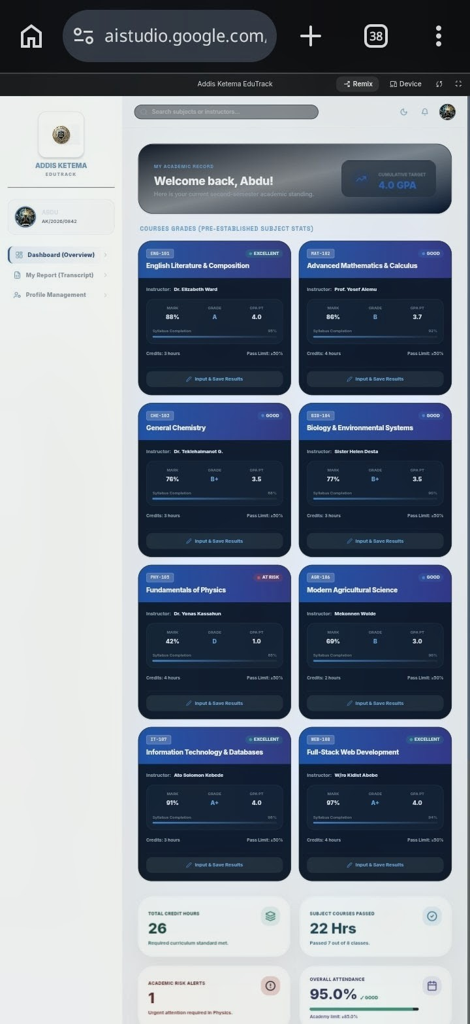

Authentication Module
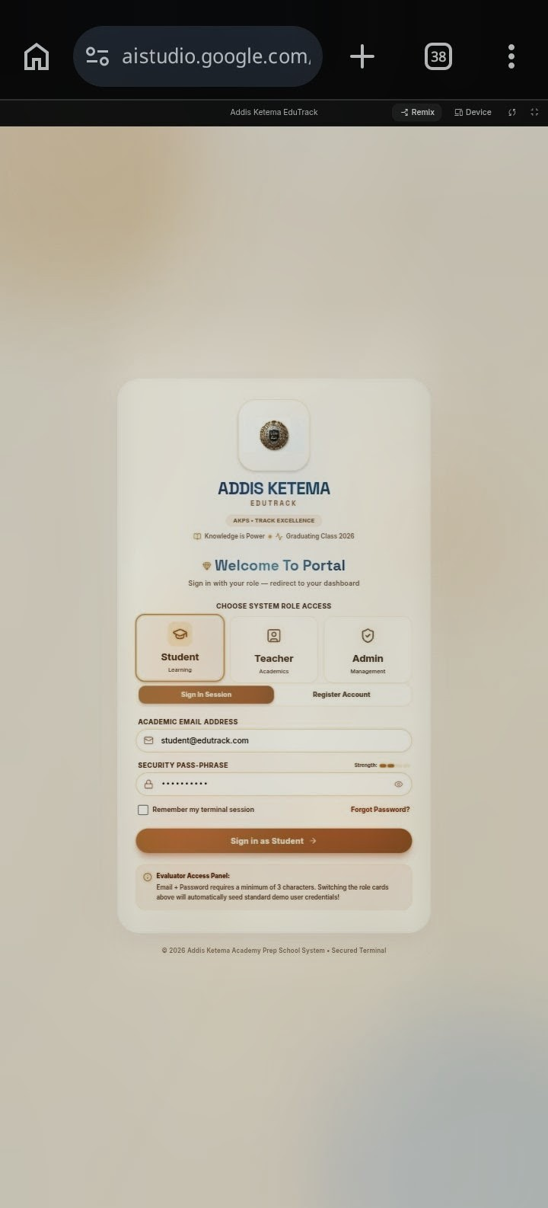

4.3 Sample Implementation Functions
CODE SNIPPET 1: Grade Calculation Function
This is from our actual project (TeacherDashboard.tsx).
B.1 Grade Calculation Function
Function calculateLocalGrade(
Assignment: number,
Quiz: number,
Exam: number
) {
Const totalMark = Math.min(
100,
Math.max(
0,
parseFloat((assignment + quiz + exam).toFixed(1))
)
);
Let gpaPoint = 0.0;
Let letterGrade = ‘F’;

If (totalMark >= 90) {
gpaPoint = 4.0;
} else if (totalMark >= 85) {
gpaPoint = 3.7;
} else if (totalMark >= 80) {
gpaPoint = 3.3;
} else if (totalMark >= 75) {
gpaPoint = 3.0;
}

Return {
totalMark,
gpaPoint,
letterGrade
};
}
This function calculates the student’s total mark by combining assignment, quiz, and examination scores. Based on the final score, the system determines the corresponding GPA value and academic grade. The function helps automate academic evaluation and reduces manual calculation errors.
B.2 GPA Calculation Function
Export function calculateGPA(grades) {
Let weightedPointsSum = 0;
Let totalCredits = 0;

Object.values(grades).forEach((g) => {
totalCredits += g.creditHours;
weightedPointsSum +=
g.gpaPoint * g.creditHours;
});

Const gpa =
totalCredits > 0
? parseFloat(
(weightedPointsSum / totalCredits)
.toFixed(2)
)
: 0.0;

Return gpa;
}
This function computes the overall Grade Point Average (GPA) by applying a weighted credit-hour calculation. The GPA is generated automatically using the student’s subject grades and credit values, providing an accurate measurement of academic performance.
B.3 User Session Management Function
Const savedSession =
localStorage.getItem(
‘ak_remember_user’
);

If (savedSession) {
Const { email, role } =
JSON.parse(savedSession);

If (role === ‘Student’) {
setRoute(‘StudentDashboard’);
} else if (role === ‘Teacher’) {
setRoute(‘TeacherDashboard’);
} else if (role === ‘Admin’) {
setRoute(‘AdminDashboard’);
}
}
This function retrieves previously stored login information and automatically redirects users to the appropriate dashboard based on their role. The feature improves user experience by reducing the need for repeated login operations.

4.4 Development Environment
The development of the ADDIS KETEMA EDUTRACK system was carried out using modern web development technologies and tools. These technologies were selected based on their reliability, flexibility, and ability to support scalable application development.
Software Tools Used
The primary technologies used during development include:
Technology | Purpose
React | Frontend user interface development
Typescript | Application logic and type safety
Html | Page structure
Css | Styling and responsiveness
JavaScript | Dynamic functionality
Supabase | Backend services and database management
Vite | Development server and build tool
Visual studio code | Source code editor
Git | Version control and project management

These technologies provided the foundation necessary to develop a modern, responsive, and maintainable web application.

4.5 System Implementation
The implementation of the system followed a modular development approach. Individual components were developed separately and later integrated into a complete academic management platform.
The system was designed around three major user categories: Administrator, Teacher, and Student. Each user category is provided with a dedicated dashboard and a set of functionalities appropriate to its responsibilities.
Role-based access control was implemented to ensure that users can access only the information and services assigned to their role.

Administrator Module
The Administrator Module serves as the central management component of the system. Through this module, administrators can manage student records, teacher information, class assignments, announcements, and system activities.
The module provides comprehensive control over academic information and user management processes.

Teacher Module
The Teacher Module enables teachers to manage academic records associated with their assigned classes and subjects.
Teachers can:
- Record student grades.
- Update assessment results until deadline.
- Monitor attendance records.
- Review student performance.
- Access class summaries and reports.
The module simplifies academic record management while reducing the possibility of manual calculation errors.

Student Module
The Student Module provides students with direct access to their academic information.
Students can:
- View grades and GPA results.
- Monitor attendance records.
- Access announcements.
- Review academic progress reports.
- View performance history.
The module promotes transparency by allowing students to track their academic performance in real time.

4.6 Authentication and Security Implementation
Security is an important aspect of academic information systems because student records contain sensitive information.
The ADDIS KETEMA EDUTRACK system implements authentication and authorization mechanisms to protect user data and prevent unauthorized access.
The authentication process involves:
1. User login using valid credentials.
2. Verification of account information.
3. Identification of user role.
4. Loading of the appropriate dashboard.
5. Restriction of access based on permissions.
Role-based access control ensures that administrators, teachers, and students can only access authorized functionalities.
Session management techniques are also used to maintain user authentication throughout system usage.

4.7 Grade Processing and Performance Calculation
One of the core functionalities of the system is academic performance evaluation.
The system processes assessment information collected from various academic activities such as:
- Assignments
- Quizzes
- Midterm examinations
- Final examinations
The collected scores are combined and processed to generate final results and academic performance indicators.
The system automatically calculates:
- Subject scores
- Overall averages
- GPA values
- Grade classifications
Automated calculations reduce human errors and improve the accuracy of academic records.
The grading scale implemented within the system is shown below:
Score Range. Grade
90 – 100………..A
80 – 89………….B
70 – 79………….C
50 – 69………….D
Below 50……….F

4.8 Challenges Encountered During Development
Several challenges were encountered during the development of the ADDIS KETEMA EDUTRACK system.
One major challenge was implementing role-based authentication. The system required different dashboards and permissions for administrators, teachers, and students. Ensuring that users could access only authorized functionalities required careful planning and testing.
Another challenge involved database synchronization and maintaining consistency between frontend components and backend records. During development, some data update operations initially produced inconsistent results, which were resolved through improved validation procedures and optimized database interactions.
Developing a responsive interface that functions correctly across different screen sizes also required additional design adjustments and testing. These challenges provided valuable learning experiences and contributed to the overall improvement of the system.

4.9 Summary of the Chapter
This chapter discussed the implementation of the ADDIS KETEMA EDUTRACK system. It presented the technologies used during development, the implementation of system modules, security mechanisms, and grade processing procedures.

CHAPTER FIVE

TESTING AND EVALUATION

5.1 Introduction

Testing is a critical phase in software development because it ensures that a system functions according to its requirements and objectives. It helps identify errors, verify functionality, evaluate performance, and improve the overall quality of the application before deployment.
For the ADDIS KETEMA EDUTRACK system, testing was conducted throughout the development process to verify that all modules operated correctly and satisfied user requirements. Various testing techniques were applied to evaluate system functionality, usability, security, and reliability.
This chapter presents the testing methodology, test cases, test results, user acceptance testing, and overall system evaluation.

5.2 Testing Methodology
The testing process focused on verifying that the system performs its intended functions accurately and efficiently. Different testing techniques were applied to evaluate individual components as well as the integrated system.

5.2.1 Functional Testing
Functional testing was conducted to verify that each feature of the system performs according to its intended purpose.
The following functionalities were tested:
User Authentication
Student Management
Teacher Management
Grade Entry
GPA Calculation
Attendance Recording
Notification Management
Dashboard Navigation
The purpose of this testing was to ensure that users could successfully perform their authorized tasks within the system.

5.2.1 Integration Testing
Integration testing was conducted to verify that individual modules interact correctly with one another.
Examples include:
Login module interacting with user dashboards.
Grade entry module updating student performance records.
Attendance module updating attendance reports.
This testing ensured smooth communication between different system components.

5.2.2 User Interface Testing
User interface testing was conducted to evaluate the usability and consistency of the system.
The testing focused on:
Navigation efficiency
Visual consistency
Dashboard accessibility
Responsiveness across different screen sizes
The objective was to provide users with an intuitive and user-friendly experience.

5.2.3 Security Testing
Security testing was performed to verify that unauthorized users could not access restricted information.

The following aspects were tested:
Login validation
User authentication
Role-based access control
Session management
This testing ensured that academic records remained protected from unauthorized access.

5.3 Test Cases and Results
Test Case | Expected Result | Actual Result | Status
User login | User accesses correct dashboard | Successful | Passed
Grade entry | Grade stored successfully | Successful | Passed
Attendance Update | Attendance saved correctly | Successful | Passed
GPA calculation | Correct GPA generated | Successful | Passed
Student result view | Student views own records only | Successful | Passed
User management | Admin manages records correctly | Successful | Passed

The following test cases were executed during system evaluation.
The test results indicate that all major system functionalities performed successfully according to the specified requirements.

5.4 User Acceptance Testing (UAT)
User Acceptance Testing (UAT) was conducted to evaluate the system from the perspective of potential end users. The objective was to determine whether the system satisfies user expectations and supports academic management activities effectively.
The testing involved three participants consisting of students and User Feedback Results

Participant | User Type | Feedback
User 1 | Student | Easy to navigate and understand
User 2 | Student | Academic information is clearly presented
User 3 | Student | Dashboard is simple and user friendly

The feedback indicated a positive user experience. Participants found the system easy to use and appreciated the centralized access to academic information.

5.5 System Evaluation

The evaluation of the ADDIS KETEMA EDUTRACK system demonstrated that the project successfully achieved its primary objectives.
The system provides:
Centralized academic information management.
Efficient grade recording and processing.
Automated GPA calculation.
Attendance monitoring capabilities.
Secure authentication and authorization.
Improved accessibility to academic records.
The implementation of role-based dashboards allows administrators, teachers, and students to perform their responsibilities efficiently while maintaining data security.

The use of modern web technologies also contributes to system responsiveness, scalability, and maintainability.

Overall, the evaluation results indicate that the system effectively addresses many challenges associated with traditional academic record management methods.

5.6 Summary of the Chapter

This chapter presented the testing and evaluation activities conducted during the development of the ADDIS KETEMA EDUTRACK system. Various testing techniques were applied to verify functionality, integration, usability, and security.

The test results demonstrated that the system operates correctly and satisfies its intended requirements. User acceptance testing also showed positive feedback from potential users, indicating that the platform is effective, reliable, and suitable for academic management purposes.

CHAPTER SIX

CONCLUSION, LIMITATIONS, AND RECOMMENDATIONS

6.1 Introduction
This chapter presents the conclusion of the project, discusses the limitations of the current system, and provides recommendations for future improvements. It summarizes the achievements of the ADDIS KETEMA EDUTRACK system and evaluates its contribution to academic management within educational institutions.

6.2 Conclusion
The ADDIS KETEMA EDUTRACK system was developed to address challenges associated with traditional academic record management methods. The project successfully achieved its primary objective of providing a centralized web-based platform for managing student grades, attendance records, academic performance, and educational information.
Throughout the development process, modern web technologies including React, TypeScript, Supabase, HTML, CSS, and JavaScript were utilized to create a responsive and user-friendly application. The implementation of role-based access control enabled administrators, teachers, and students to interact with the system according to their respective responsibilities while maintaining data security and integrity.
The system provides several important functionalities including student management, teacher management, grade recording, GPA calculation, attendance tracking, announcements, notifications, and performance monitoring. These features contribute to improved efficiency, reduced administrative workload, and increased transparency in academic record management.
Testing results demonstrated that the system performs effectively and satisfies the functional requirements identified during the analysis and design phases. The successful implementation of the project illustrates how digital technologies can be applied to improve educational administration and support better academic management practices.
Overall, the ADDIS KETEMA EDUTRACK system provides a practical and reliable solution for managing academic information and represents an important step toward the digital transformation of educational institutions.

6.3 Limitations of the System
Although the system successfully fulfills its intended objectives, several limitations were identified during development and evaluation.
One limitation is the dependence on internet connectivity. Since the system relies on cloud-based services and online database communication, users must have access to a stable internet connection to utilize all functionalities effectively.
Another limitation is the absence of a parent portal. The current version of the system focuses on administrators, teachers, and students. Parents or guardians cannot directly access student performance information through a dedicated interface.
The system also provides only English language support. Educational institutions with users who prefer local languages may require multilingual functionality to improve accessibility and user experience.
In addition, the current version does not include advanced analytical capabilities such as academic performance prediction, intelligent recommendations, or machine learning-based insights. Performance evaluation is based on recorded academic data and standard calculations.
Furthermore, although the system supports attendance management and academic reporting, it does not currently integrate with external communication services such as SMS or email notification platforms.
Finally, the system was developed primarily for small and medium-sized educational institutions. Large-scale deployment involving thousands of users may require additional optimization and infrastructure improvements.

6.4 Recommendations
Based on the findings of this project, several recommendations can be made for future development and deployment.
Educational institutions intending to adopt the system should ensure adequate internet infrastructure to support continuous access to cloud-based services. Proper user training should also be provided to administrators, teachers, and students to maximize system effectiveness.

Future developers should focus on enhancing scalability and performance to support larger educational environments. Additional security features such as two-factor authentication may also be implemented to strengthen user account protection.
Regular maintenance and software updates are recommended to ensure long-term reliability, security, and compatibility with evolving technologies.
It is also recommended that future versions of the system incorporate advanced reporting tools and data visualization features to assist administrators and teachers in making informed academic decisions.

6.5 Future Enhancements
Several improvements can be implemented in future versions of the ADDIS KETEMA EDUTRACK system.
One potential enhancement is the development of dedicated mobile applications for Android and iOS devices. Mobile applications would improve accessibility and provide a more convenient user experience.
The implementation of a parent dashboard would allow parents and guardians to monitor student attendance, grades, and academic progress more effectively.
Another valuable enhancement would be the integration of SMS and email notification services. These features would enable automated communication regarding announcements, attendance issues, examination results, and important academic updates.
The system could also benefit from multilingual support, including local languages such as Amharic. This would improve accessibility for a wider range of users.
Advanced analytics and artificial intelligence technologies could be incorporated to provide performance prediction, risk analysis, and personalized academic recommendations for students.
Offline functionality with automatic synchronization could also be introduced to support environments where internet connectivity is limited or inconsistent.

These enhancements would further increase the usefulness, accessibility, and effectiveness of the system while supporting the evolving needs of educational institutions.

6.6 Final Remark
The successful completion of the ADDIS KETEMA EDUTRACK project demonstrates the practical application of modern software engineering principles in addressing real-world educational challenges. By providing a centralized and secure platform for academic management, the system contributes to improved efficiency, transparency, and accessibility within educational institutions.
The project not only achieved its technical objectives but also provided valuable experience in system analysis, design, implementation, testing, and project management. With future enhancements and continuous improvement, the system has the potential to become a comprehensive academic management solution capable of supporting a broader range of educational requirements.

References
1. Pressman, R. S. (2014). Software Engineering: A Practitioner’s Approach. 8th Edition. McGraw-Hill Education.
2. Sommerville, I. (2016). Software Engineering. 10th Edition. Pearson Education Limited.
3. Elmasri, R., & Navathe, S. B. (2016). Fundamentals of Database Systems. Pearson.
4. Dennis, A., Wixom, B. H., & Roth, R. M. (2018). Systems Analysis and Design. Wiley.
5. Kendall, K. E., & Kendall, J. E. (2019). Systems Analysis and Design. Pearson.
6. Laudon, K. C., & Laudon, J. P. (2021). Management Information Systems: Managing the Digital Firm. Pearson.

Appendix
ER Diagram Overview
├── .env.example # Environment variables template (Supabase keys, configs)
├── .gitignore # Files excluded from version control
├── index.html # Main HTML entry point of the app
├── metadata.json # App configuration and metadata
├── package.json # Project dependencies and scripts
├── tsconfig.json # TypeScript configuration
├── vite.config.ts # Vite build & development configuration
│
└── src/
├── assets/ # Static files (images, logos, icons)
│
├── components/ # UI pages & dashboards
│ ├── AdminDashboard.tsx # Admin control panel (manage users & system)
│ ├── TeacherDashboard.tsx # Teacher panel (grades & class management)
│ ├── StudentDashboard.tsx # Student panel (view results only)
│ ├── LoginPage.tsx # Authentication page (role-based login)
│ ├── SplashWelcome.tsx # Intro/loading screen
│ └── AvatarCam.tsx # Profile/avatar handling UI
│
├── data/ # Core logic & temporary data storage
│ └── mockData.ts # Students, teachers, grade logic, state updates
│
├── App.tsx # Main app structure & routing
├── main.tsx # React entry point

Sample Implementation Functions
B.1 Grade Calculation Function
Function calculateLocalGrade(
Assignment: number,
Quiz: number,
Exam: number
) {
Const totalMark = Math.min(
100,
Math.max(
0,
parseFloat((assignment + quiz + exam).toFixed(1))
)
);

Let gpaPoint = 0.0;
Let letterGrade = ‘F’;

If (totalMark >= 90) {
gpaPoint = 4.0;
} else if (totalMark >= 85) {
gpaPoint = 3.7;
} else if (totalMark >= 80) {
gpaPoint = 3.3;
} else if (totalMark >= 75) {
gpaPoint = 3.0;
}

Return {
totalMark,
gpaPoint,
letterGrade
};
}
This function calculates the student’s total mark by combining assignment, quiz, and examination scores. Based on the final score, the system determines the corresponding GPA value and academic grade. The function helps automate academic evaluation and reduces manual calculation errors.
B.2 GPA Calculation Function
Export function calculateGPA(grades) {
Let weightedPointsSum = 0;
Let totalCredits = 0;

Object.values(grades).forEach((g) => {
totalCredits += g.creditHours;
weightedPointsSum +=
g.gpaPoint * g.creditHours;
});

Const gpa =
totalCredits > 0
? parseFloat(
(weightedPointsSum / totalCredits)
.toFixed(2)
)
: 0.0;

Return gpa;
}
This function computes the overall Grade Point Average (GPA) by applying a weighted credit-hour calculation. The GPA is generated automatically using the student’s subject grades and credit values, providing an accurate measurement of academic performance.
B.3 User Session Management Function
Const savedSession =
localStorage.getItem(
‘ak_remember_user’
);

If (savedSession) {
Const { email, role } =
JSON.parse(savedSession);

If (role === ‘Student’) {
setRoute(‘StudentDashboard’);
} else if (role === ‘Teacher’) {
setRoute(‘TeacherDashboard’);
} else if (role === ‘Admin’) {
setRoute(‘AdminDashboard’);
}
}
This function retrieves previously stored login information and automatically redirects users to the appropriate dashboard based on their role. The feature improves user experience by reducing the need for repeated login operations.
Installation Guide
Install Node.js
Download project files
Open in Visual Studio Code
Run npm install
Configure Supabase credentials
Run npm run dev

